Name:- Saiganesh Kosari

**Assignment 2**

**Project 3**

**Create two linux instances,Use the first free linux AMI**

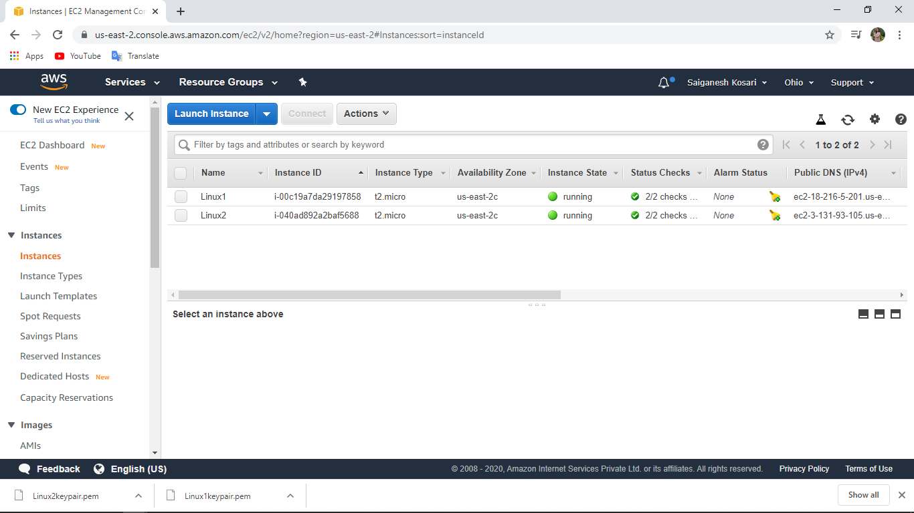

**Launch both instances using Mobaxterm**

Linux 1 (18.216.5.201)

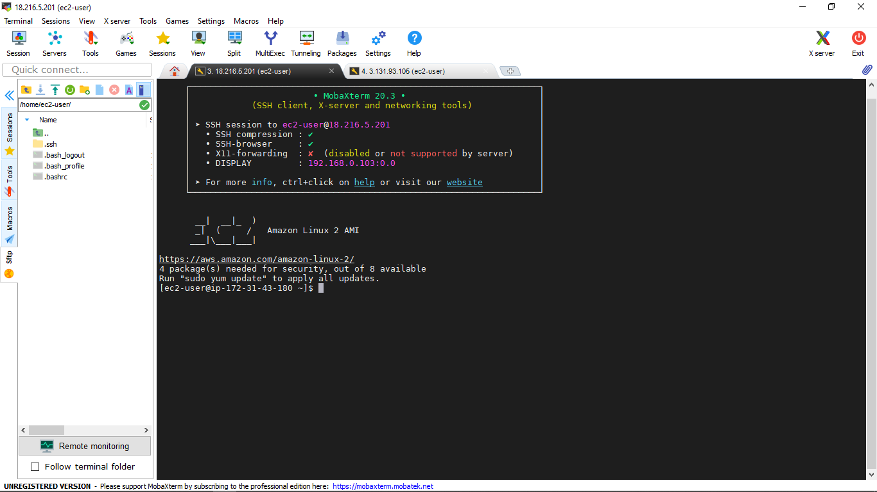

Linux 2 (3.131.93.105)

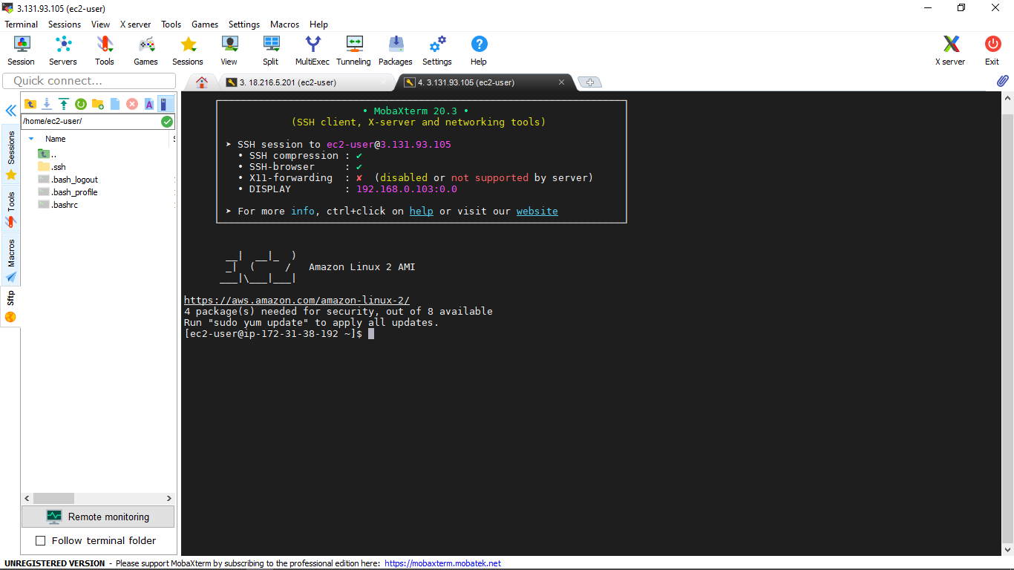

**Host html login webpage on both servers and Check is application is deployed on both servers by copy pasting the public ip of the servers into the browser**

Linux 1 (18.216.5.201)

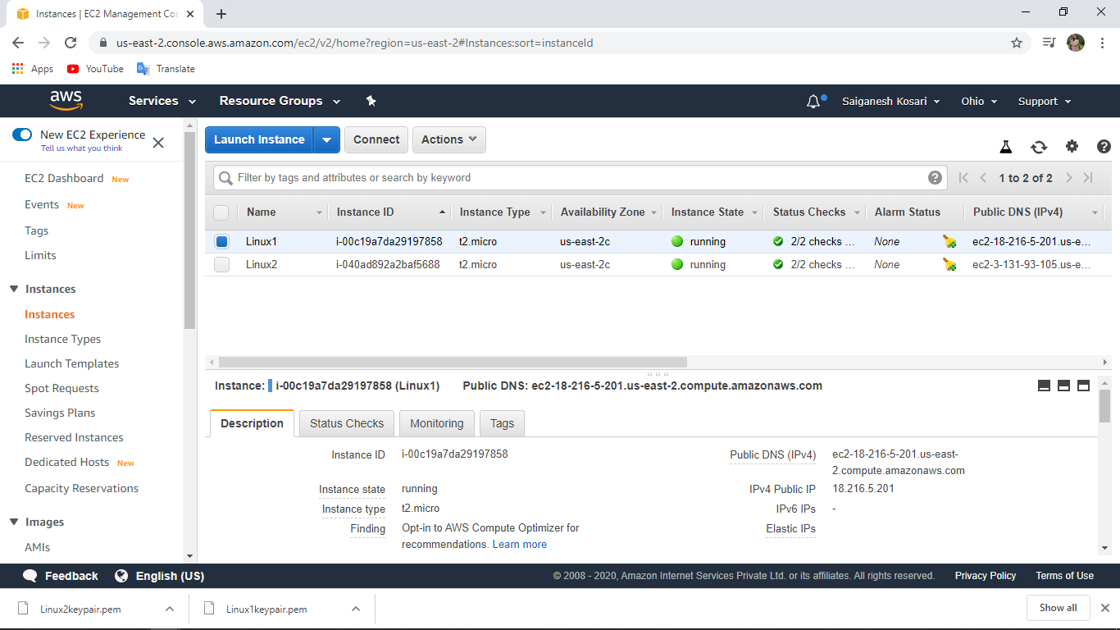

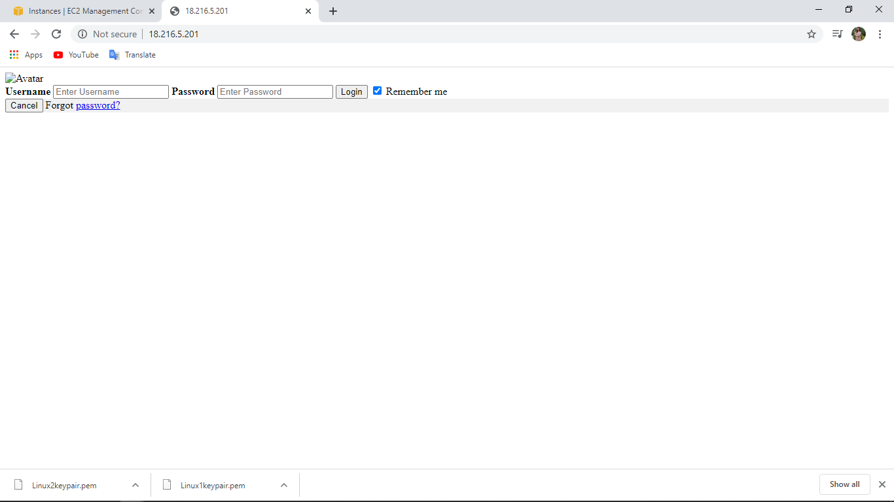

Linux 2 (3.131.93.105)

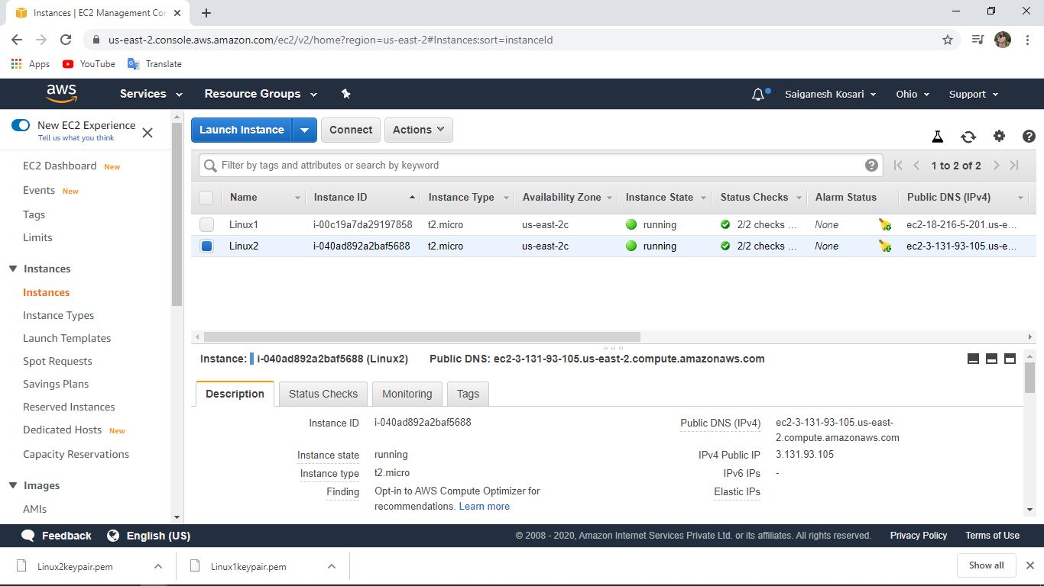

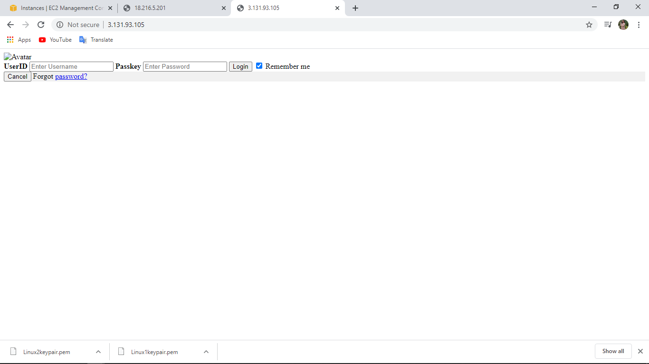

Top of Form

**Create a application Load balancer with the above two instances as targets**

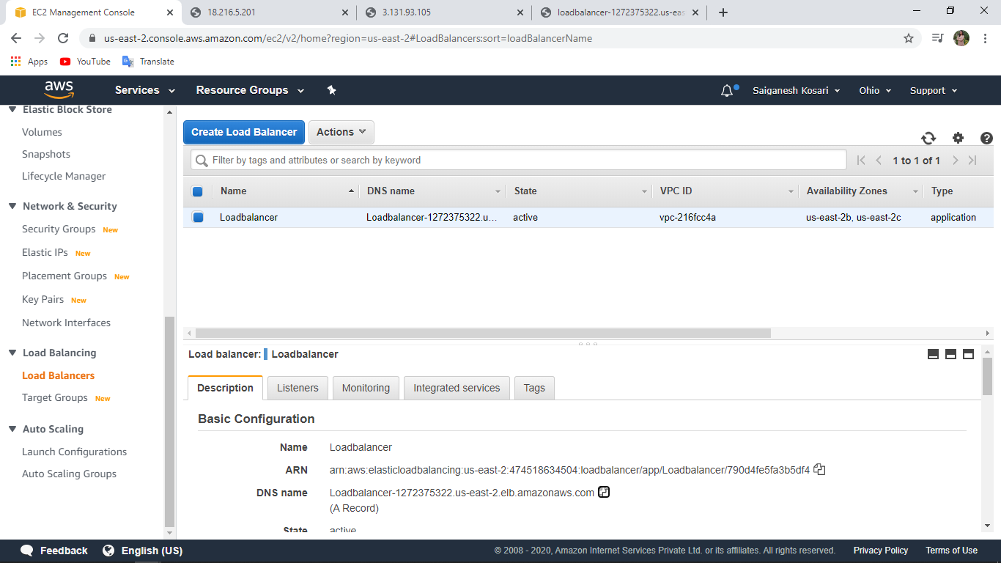

**Check the functioning of ELB (passed)**

